Benabdi Sidali
DAB July 2025
NYC Motor Vehicles Crashes Post-2020 ANALYSIS: Contributing Factors to Advance Vision Zero
Comprehensive Analytics Report
Introduction:
The City of New York is committed to its Vision Zero initiative, which aims to eliminate all traffic fatalities and serious injuries among its residents. However, this important mission is now facing new hurdles in the post-2020 landscape. Changes in traffic patterns, a rise in cycling, and evolving driver behaviors have resulted in a troubling number of severe crashes. Unfortunately, the current safety measures haven't fully adjusted to these new challenges, leaving vulnerable road users at risk of avoidable harm. Relying on data from before 2020 could mean missing out on the realities of today’s streets and the pressing need for updated solutions. This project utilizes detailed crash data from 2020 and beyond to carefully pinpoint the most hazardous factors and their prevalence. By doing this, it equips city agencies with practical insights to better allocate resources and speed up efforts toward creating a safer and more equitable urban environment.

Raw data source : https://catalog.data.gov/dataset/motor-vehicle-collisions-crashes

Data Selection and Preparation:
The focus of this Capstone Project revolves around the Motor Vehicle Crashes dataset, which comes straight from the Open Data portal (Data.gov). This dataset is essentially a single table packed with around 29 columns and over a million records, each one detailing a police-reported crash incident. To make sure this analysis captures the latest public safety issues and the current traffic landscape, especially considering the major changes in behavior and traffic volume that followed the 2020 pandemic, it was narrowed down to incidents that happened between January 1, 2021, and January 2025.
The initial phase of this project focused on making sure the dataset was ready for analysis. This meant that before diving into any research questions, all the necessary data transformations had to be completed.
All date and time fields have been accurately converted to their appropriate formats. Rows containing missing values in the location, latitude, or longitude fields have been removed. The Collision ID field was correctly formatted as the first column. Uniform categories for contributing factors and vehicle type codes were established to resolve issues like subjectivity, inconsistent capitalization, duplicate entries, abbreviations, and typos. A separate data frame for borough, zip code, and street name preserved geographic data integrity, while missing values were removed or indexed.
All Data preparation was done on Python using the pandas and numpy libraries.

Analytical Process and Methodology:
The analytical process began by formulating several key research questions to guide the investigation. These included identifying which borough and street/cross-street combinations exhibit the highest concentration of high-severity crashes, determining peak crash times and dates for high-severity versus property damage only incidents, assessing which primary contributing factor is most lethal, defined as having the highest likelihood of resulting in a fatality, and evaluating whether significant differences exist in the distribution of vehicle type code such as SUVs versus passenger vehicles when comparing fatal crashes to those involving only property damage.
Additional focus was placed on identifying the most common contributing factors in crashes involving pedestrian or cyclist injuries or fatalities, as well as examining how the severity of crashes involving vulnerable road users varies based on the number of vehicles involved.
To address these questions, the main data frame was enhanced with several new fields: KSI(killed and seriously injured) count, a binary flag (is_vulnerable_crash) to identify incidents involving pedestrians and cyclists, a crash outcome field categorizing each event as fatal, injury, or property damage only and a time of day category grouping crash hours into five segments. Furthermore, three separate tables were created to summarize the main contributing factors, the most lethal vehicle types, and the most dangerous boroughs ranked by crash severity rather than volume. After thorough data cleaning and preparation, the main data frame and summary tables were saved as CSV files, ready for visualization. The next phase involves importing these CSVs into Tableau to develop visualizations that effectively communicate findings and facilitate further exploration of insights.

Presentation of key findings and insights:
The visualizations created in Tableau, featuring a variety of graphs, charts, and a comprehensive map, uncover some important insights. When we take a closer look at the NYC Crashes Map, it becomes clear that crash incidents are heavily clustered within the street grids of Manhattan, Brooklyn, and Queens. Interestingly, fatal incidents are spread throughout these areas rather than being confined to specific spots. Brooklyn and Queens report the highest numbers of crashes and fatalities, while Staten Island, despite having the fewest crashes overall, shows the highest lethality rate per incident. Looking at the timing, crashes tend to peak during midday and evening rush hours throughout the week, with late-night weekends seeing a significant increase compared to late nights on weekdays. Most injuries and property-damage crashes occur during those busy midday and evening times, while fatal crashes are more likely to happen late at night. Passenger vehicles are involved in the majority of collisions, followed by trucks, which also play a big role in injury and property-damage incidents. Motorcycles and scooters, on the other hand, have a surprisingly high rate of injury-related crashes and the highest percentage of fatalities. In contrast, passenger vehicles mostly lead to property-damage-only incidents. Motorcycles and scooters also show the highest lethality rates, with trucks, city/service vehicles, and other types showing elevated rates compared to passenger vehicles. Distraction and traffic violations are the most common factors contributing to crashes involving vulnerable road users, with unsafe driving and errors by pedestrians or cyclists also being significant contributors. Notably, errors by pedestrians or cyclists, infrastructure issues, and impairment are linked to the highest lethality rates, while distraction, despite being frequent, tends to have a lower lethality rate. Most crashes involving vulnerable road users involve one or two vehicles, but the average number of casualties tends to rise when three or more vehicles are involved.
It turns out that the majority of deadly motor vehicle accidents tend to happen on limited-access roads and expressways, like the Belt Parkway, Major Deegan, Henry Hudson, LIE, and Grand Central. Interestingly, just a few specific corridors in each borough account for a surprisingly high number of these tragic incidents.
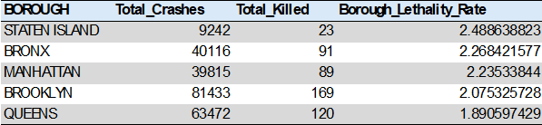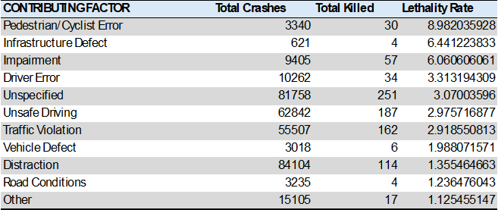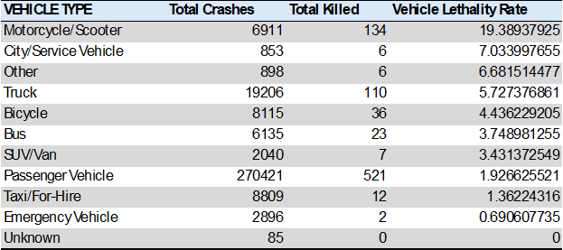

Discussion of recommendations and potential next steps or real-world applications:
The data reveals that crashes are scattered throughout the city, with a particularly high concentration in Manhattan, Brooklyn, and Queens. When we break it down by borough, Brooklyn and Queens lead in both crashes and deaths, while Staten Island sees fewer crashes but a greater likelihood that a crash will result in a fatality. This indicates that citywide strategies need to be paired with tailored plans for each borough, for example, targeting Brooklyn and Queens for high crash volume and Staten Island for its higher risk that a crash becomes fatal. The time of day analysis shows that most crashes occur during midday and evening rush hours, making these the prime times for implementing general safety measures, enforcement, and educational initiatives to reach the largest audience. However, fatal crashes tend to spike at night and late at night, highlighting the need for targeted late-night enforcement, impaired-driving checks, and speed control on critical routes. Vehicle data indicates that while passenger vehicles are involved in most crashes, motorcycles and trucks pose a greater risk when they are part of an incident. This underscores the importance of motorcycle safety programs, enhanced protections for riders, and stricter safety regulations for trucks. The visuals on factors and vulnerable road users point to distractions, traffic violations, and high-risk elements like impairment and errors by pedestrians and cyclists, suggesting a combination of education, changes in street design, and focused enforcement efforts. Lastly, the corridor view indicates that many fatalities occur on major expressways and high-speed roads. These areas are prime candidates for additional speed cameras, redesigns to slow down traffic, clearer signage, and improved lighting, making them key locations to monitor for future progress.
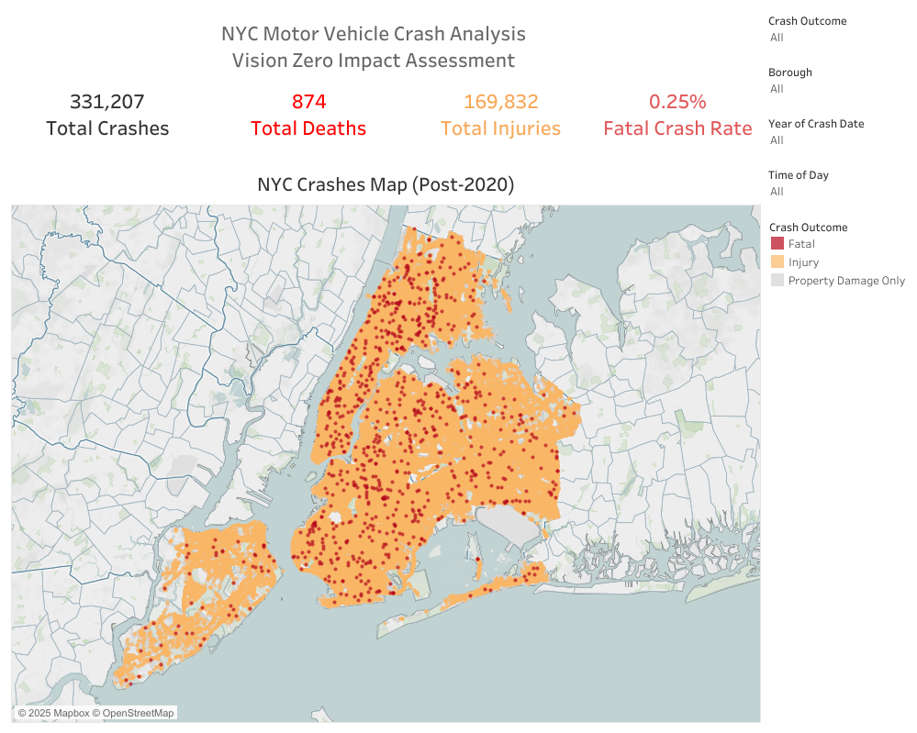

ff

